**DAILY ONLINE ACTIVITIES SUMMARY**

|  |  |  |  |  |  |  |  |  |
| --- | --- | --- | --- | --- | --- | --- | --- | --- |
| **Date:** | **07/06/2020** | | | | | **Name:** | **Shwetha** | |
| **Sem & Sec** | **8th B** | | | | | **USN:** | **4AL16CS101** | |
| **Online Test Summary** | | | | | | | | |
| **Subject** | | **-** | | | | | | |
| **Max. Marks** | | **-** | | **Score** | | | **-** | |
| **Certification Course Summary** | | | | | | | | |
| **Course** | **Introduction to cyber security** | | | | | | | |
| **Certificate Provider** | | | **Great learning** | | **Duration** | | | **7hr** |
| **Coding Challenges** | | | | | | | | |
| **Problem Statement:**  **Python program to display the Fibonacci sequence.** | | | | | | | | |
| **Status: Solved**  **Solution link: https://github.com/alvas-education-foundation/Shwetha-** | | | | | | | | |
| **Uploaded the report in Github** | | | | | **Yes** | | | |
| **If yes Repository name** | | | | | **Shwetha-** | | | |
| **Uploaded the report in slack** | | | | | **Yes** | | | |

Certification Course Details:

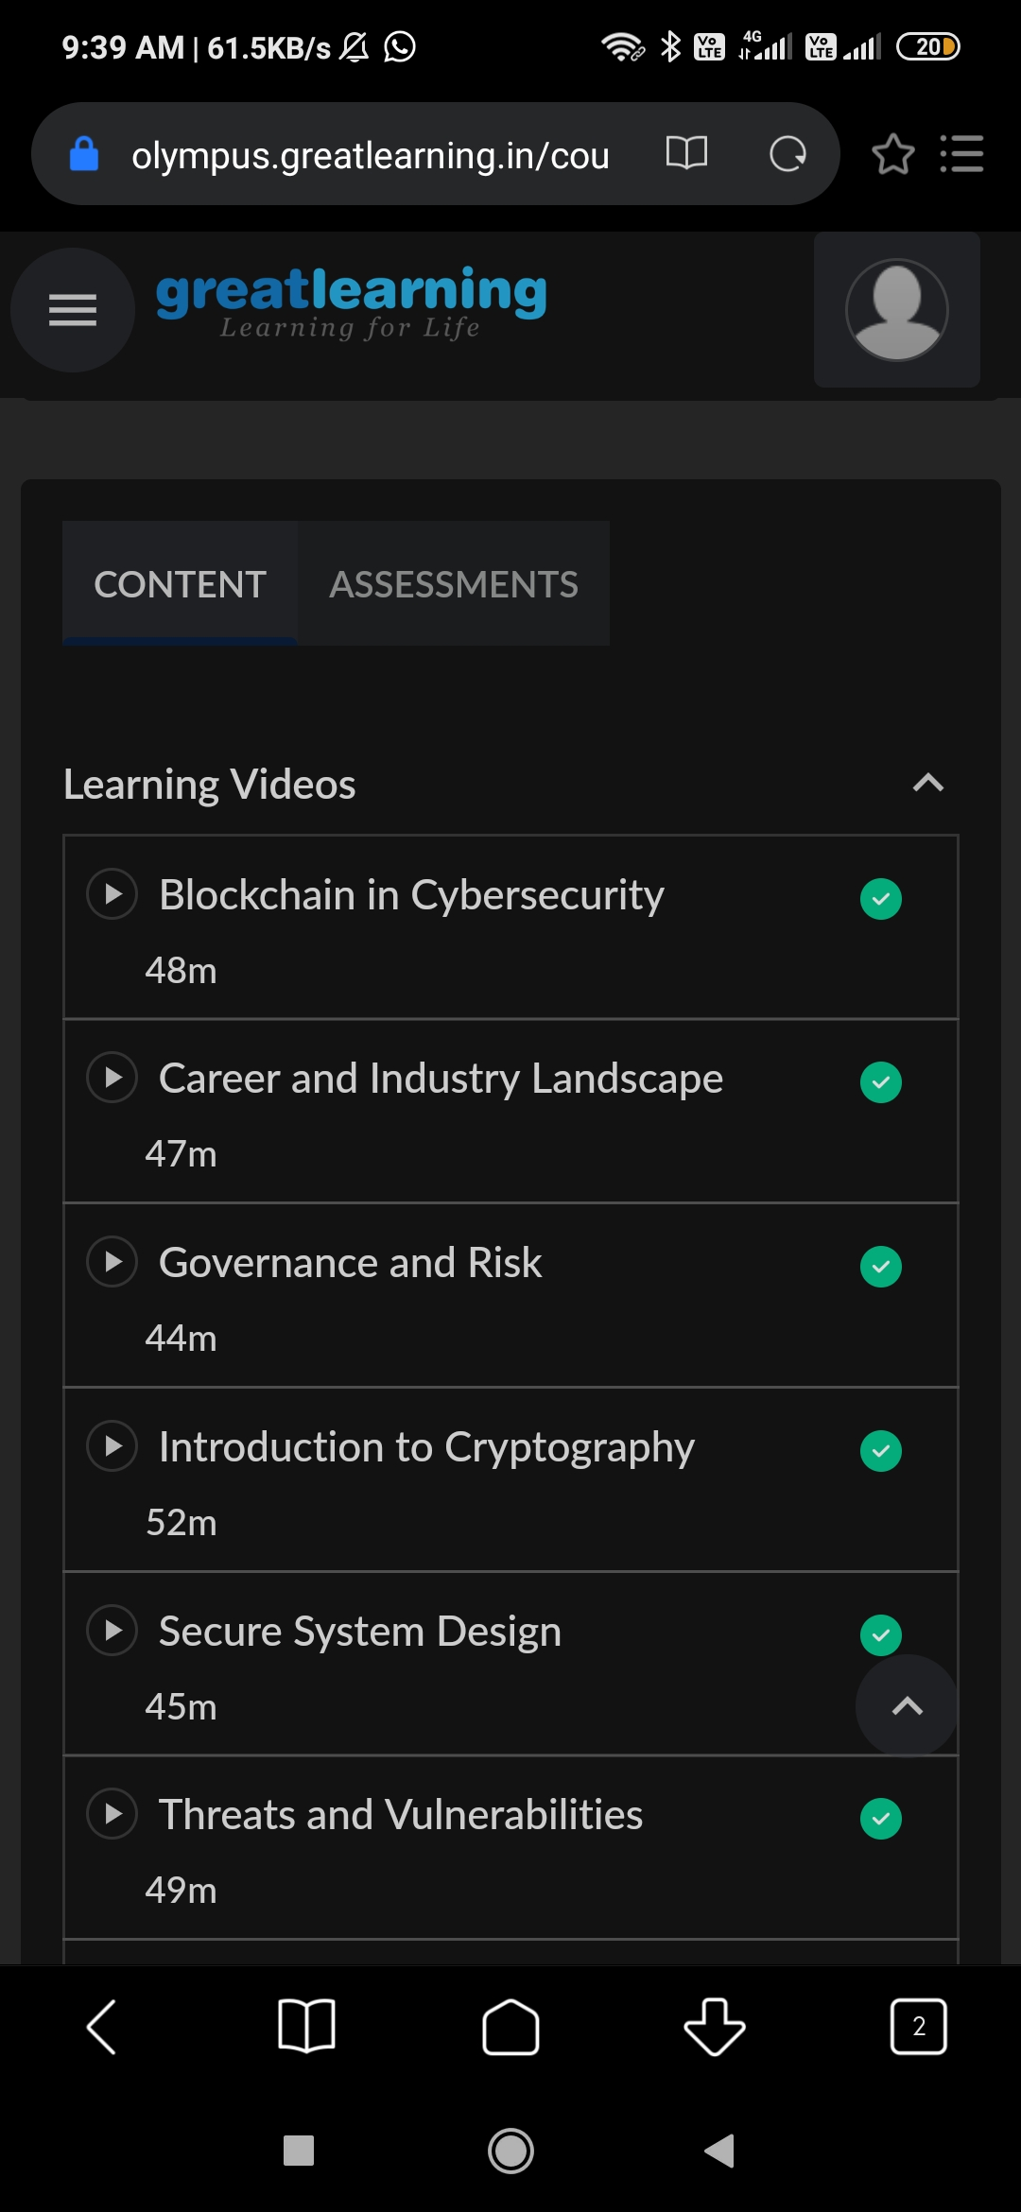

Coding Challenges Details:

# Python program to display the Fibonacci sequence

def recur_fibo(n):

if n <= 1:

return n

else:

return(recur_fibo(n-1) + recur_fibo(n-2))

nterms = 10

if nterms <= 0:

print("Plese enter a positive integer")

else:

print("Fibonacci sequence:")

for i in range(nterms):

print(recur_fibo(i))

listThree.extend(oddElements)

listThree.extend(EvenElement)

print(listThree)